7th , Apr, 2026
Assignment: 02
CLO 2: Apply computer vision techniques for solving practical problems.

Submitted By:
Shafi Azam (SP24-BAI-047)
Muhammad Hamza Habib (SP24-BAI-034)

Submitted To: Dr. Tahir Mustafa Madni
Subject: CV


Department of Computer Science
Comsats University Islamabad
Islamabad Campus

Scattered Data Interpolation
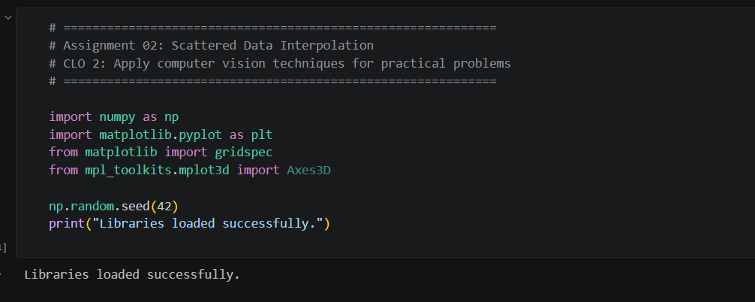

Step 1: Generate the Ground-Truth Function
# ============================================================
# STEP 1: Generate a smoothly varying 1-D function
# by summing sinusoids of random amplitudes & frequencies
# ============================================================

def generate_true_function(x, n_components=5, seed=42):
"""
Sum of n_components sinusoids with random amplitudes and frequencies.
This is our 'ground truth' function f(x).
"""
rng = np.random.RandomState(seed)
amplitudes = rng.uniform(0.5, 2.0, n_components)
frequencies = rng.uniform(0.5, 3.0, n_components)
phases = rng.uniform(0, 2*np.pi, n_components)

y = np.zeros_like(x, dtype=float)
for A, f, phi in zip(amplitudes, frequencies, phases):
y += A * np.sin(2 * np.pi * f * x + phi)
return y

# Dense grid for "ground truth"
x_true = np.linspace(0, 1, 500)
y_true = generate_true_function(x_true)

plt.figure(figsize=(10, 4))
plt.plot(x_true, y_true, 'k-', linewidth=2, label='True function f(x)')
plt.title('Step 1 — Ground Truth Function (Sum of Sinusoids)', fontsize=14)
plt.xlabel('x')
plt.ylabel('f(x)')
plt.legend()
plt.grid(True, alpha=0.3)
plt.tight_layout()
plt.show()

print(f"True function range: [{y_true.min():.3f}, {y_true.max():.3f}]")

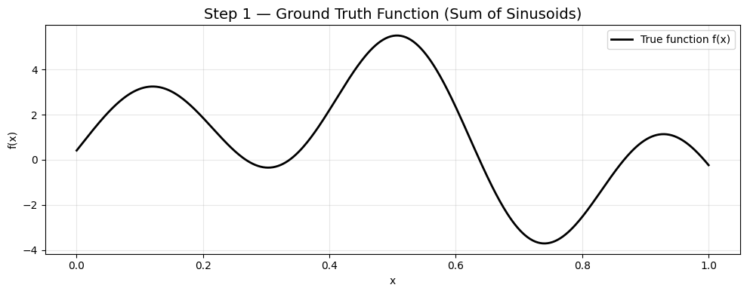


Step 2: Sample at Random Locations
# ============================================================
# STEP 2: Sample the function at N random locations
# ============================================================

N_SAMPLES = 40 # number of random samples

rng = np.random.RandomState(7)
x_samples = np.sort(rng.uniform(0, 1, N_SAMPLES)) # sorted for clean plots
y_samples = generate_true_function(x_samples)

# Add a tiny amount of noise to simulate real measurements
noise_std = 0.05
y_noisy = y_samples + rng.normal(0, noise_std, N_SAMPLES)

plt.figure(figsize=(10, 4))
plt.plot(x_true, y_true, 'k-', linewidth=2, label='True function')
plt.scatter(x_samples, y_noisy, color='red', zorder=5, s=50,
edgecolors='darkred', label=f'Noisy samples (N={N_SAMPLES})')
plt.title('Step 2 — Random Samples from the Function', fontsize=14)
plt.xlabel('x')
plt.ylabel('f(x)')
plt.legend()
plt.grid(True, alpha=0.3)
plt.tight_layout()
plt.show()

print(f"Sampled {N_SAMPLES} points. Noise std = {noise_std}")

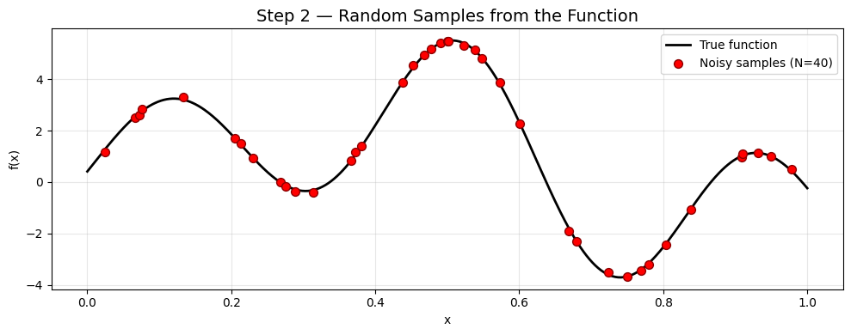

Step 3a: RBF Interpolation (from scratch with NumPy)
# ============================================================
# STEP 3: Scattered Data Interpolation Techniques
#
# Technique 1 — Radial Basis Function (RBF) Interpolation
# f(x) = sum_i w_i * phi(||x - x_i||)
# phi(r) = exp(-r^2 / (2*sigma^2)) [Gaussian RBF]
# ============================================================

def rbf_fit(x_train, y_train, sigma):
"""
Fit RBF interpolant.
Builds N×N kernel matrix Phi and solves Phi @ w = y for weights w.

Parameters
----------
x_train : (N,) array of sample locations
y_train : (N,) array of sample values
sigma : RBF width (bandwidth)

Returns
-------
w : (N,) weight vector
"""
# Pairwise distance matrix ||x_i - x_j||
diff = x_train[:, None] - x_train[None, :] # (N, N)
Phi = np.exp(-diff**2 / (2 * sigma**2)) # (N, N) kernel matrix

# Solve for weights: add small regularisation for numerical stability
lam = 1e-6
w = np.linalg.solve(Phi + lam * np.eye(len(x_train)), y_train)
return w

def rbf_predict(x_new, x_train, w, sigma):
"""
Predict at new locations using fitted RBF weights.
"""
diff = x_new[:, None] - x_train[None, :] # (M, N)
Phi = np.exp(-diff**2 / (2 * sigma**2)) # (M, N)
return Phi @ w # (M,)

# --- Fit with a chosen sigma ---
sigma_rbf = 0.08
w_rbf = rbf_fit(x_samples, y_noisy, sigma=sigma_rbf)
y_rbf = rbf_predict(x_true, x_samples, w_rbf, sigma=sigma_rbf)

plt.figure(figsize=(10, 4))
plt.plot(x_true, y_true, 'k-', linewidth=2, label='True function')
plt.plot(x_true, y_rbf, 'b--', linewidth=2, label=f'RBF fit (σ={sigma_rbf})')
plt.scatter(x_samples, y_noisy, color='red', zorder=5, s=40,
edgecolors='darkred', label='Samples')
plt.title('Step 3a — RBF (Gaussian) Interpolation', fontsize=14)
plt.xlabel('x'); plt.ylabel('f(x)')
plt.legend(); plt.grid(True, alpha=0.3)
plt.tight_layout(); plt.show()
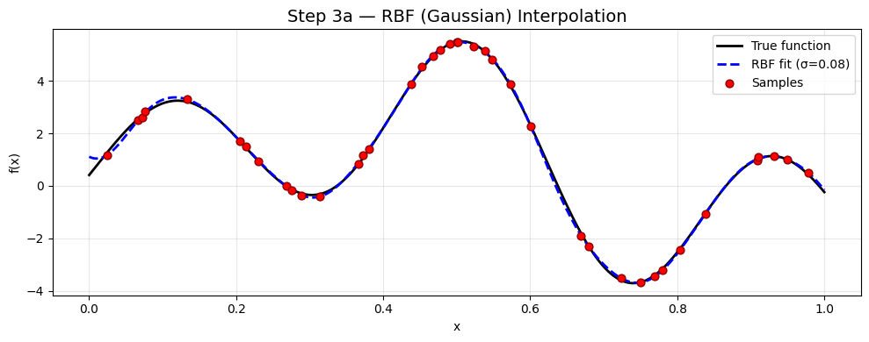

Step 3b: Polynomial (Least-Squares) Regression
# ============================================================
# Technique 2 — Polynomial Least-Squares Regression
# Build Vandermonde matrix V and solve V @ c = y in least-squares sense
# ============================================================

def poly_fit(x_train, y_train, degree):
"""
Fit polynomial of given degree using the normal equations (NumPy lstsq).
Returns coefficient vector c such that sum_k c[k] * x^k ≈ y.
"""
# Vandermonde matrix (N, degree+1)
V = np.vander(x_train, N=degree + 1, increasing=True)
# Least-squares solution
c, _, _, _ = np.linalg.lstsq(V, y_train, rcond=None)
return c

def poly_predict(x_new, c):
"""Evaluate polynomial with coefficients c at x_new."""
V = np.vander(x_new, N=len(c), increasing=True)
return V @ c

# Fit polynomials of various degrees
degrees = [5, 10, 15, 20]
colors = ['green', 'orange', 'purple', 'brown']

plt.figure(figsize=(10, 4))
plt.plot(x_true, y_true, 'k-', linewidth=2, label='True function')
plt.scatter(x_samples, y_noisy, color='red', zorder=5, s=40,
edgecolors='darkred', label='Samples')

poly_results = {}
for deg, col in zip(degrees, colors):
c = poly_fit(x_samples, y_noisy, deg)
y_pred = poly_predict(x_true, c)
poly_results[deg] = (c, y_pred)
plt.plot(x_true, y_pred, '--', color=col, linewidth=1.8,
label=f'Poly deg {deg}')

plt.ylim(-10, 10)
plt.title('Step 3b — Polynomial Least-Squares Regression', fontsize=14)
plt.xlabel('x'); plt.ylabel('f(x)')
plt.legend(loc='upper right', fontsize=9); plt.grid(True, alpha=0.3)
plt.tight_layout(); plt.show()

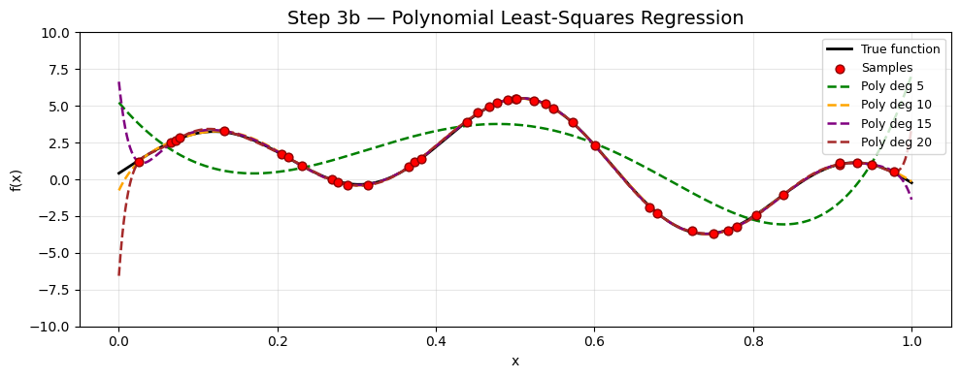
Step 3c: Piecewise Linear Interpolation
# ============================================================
# Technique 3 — Piecewise Linear (Nearest-Neighbour Weighted) Interpolation
# Classic tent-function / linear barycentric interpolation in NumPy
# ============================================================

def piecewise_linear_predict(x_new, x_train, y_train):
"""
For each query point find the two nearest training points
and linearly interpolate between them.
"""
y_pred = np.zeros_like(x_new)
for i, xq in enumerate(x_new):
dists = np.abs(x_train - xq)
idx = np.argsort(dists)
i1, i2 = idx[0], idx[1]
x1, x2 = x_train[i1], x_train[i2]
y1, y2 = y_train[i1], y_train[i2]
if x1 == x2:
y_pred[i] = y1
else:
t = (xq - x1) / (x2 - x1)
y_pred[i] = (1 - t) * y1 + t * y2
return y_pred

y_linear = piecewise_linear_predict(x_true, x_samples, y_noisy)

plt.figure(figsize=(10, 4))
plt.plot(x_true, y_true, 'k-', linewidth=2, label='True function')
plt.plot(x_true, y_linear, 'm-', linewidth=1.8, label='Piecewise Linear')
plt.scatter(x_samples, y_noisy, color='red', zorder=5, s=40,
edgecolors='darkred', label='Samples')
plt.title('Step 3c — Piecewise Linear Interpolation', fontsize=14)
plt.xlabel('x'); plt.ylabel('f(x)')
plt.legend(); plt.grid(True, alpha=0.3)
plt.tight_layout(); plt.show()

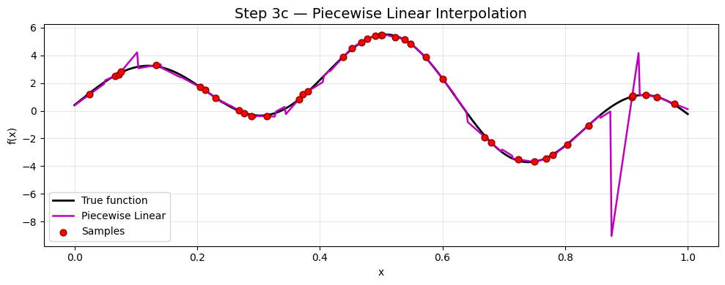

Step 4: Measure Fitting Error
# ============================================================
# STEP 4: Measure fitting error on a regular evaluation grid
# Metrics: RMSE and MAE
# ============================================================

def rmse(y_pred, y_ref):
return np.sqrt(np.mean((y_pred - y_ref)**2))

def mae(y_pred, y_ref):
return np.mean(np.abs(y_pred - y_ref))

# Evaluate all methods on the dense grid x_true
errors = {}
errors['RBF (σ=0.08)'] = {'rmse': rmse(y_rbf, y_true),
'mae': mae(y_rbf, y_true)}
errors['Piecewise Lin.'] = {'rmse': rmse(y_linear, y_true),
'mae': mae(y_linear, y_true)}

for deg in degrees:
_, y_pred = poly_results[deg]
# Clip extreme polynomial values before measuring (Runge phenomenon)
y_clipped = np.clip(y_pred, y_true.min() - 5, y_true.max() + 5)
errors[f'Poly deg {deg}'] = {'rmse': rmse(y_clipped, y_true),
'mae': mae(y_clipped, y_true)}

# Print table
print(f"{'Method':<20} {'RMSE':>8} {'MAE':>8}")
print("-" * 42)
for method, vals in errors.items():
print(f"{method:<20} {vals['rmse']:>8.4f} {vals['mae']:>8.4f}")

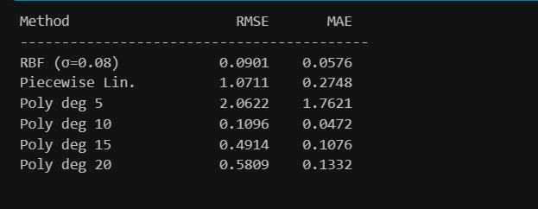

Step 5: Cross-Validation to Choose Best σ for RBF
# ============================================================
# STEP 5: Cross-Validation to tune the RBF bandwidth σ
# Leave-One-Out CV entirely in NumPy
# ============================================================

def loo_cv_rmse(x_train, y_train, sigma, lam=1e-6):
"""Leave-One-Out CV error for RBF with bandwidth sigma."""
N = len(x_train)
errors = np.zeros(N)
for i in range(N):
# Indices excluding i
idx = np.concatenate([np.arange(i), np.arange(i+1, N)])
x_tr = x_train[idx]
y_tr = y_train[idx]
w = rbf_fit(x_tr, y_tr, sigma)
yp = rbf_predict(x_train[i:i+1], x_tr, w, sigma)
errors[i] = (yp[0] - y_train[i])**2
return np.sqrt(np.mean(errors))

# Sweep over sigma values
sigma_values = np.logspace(-2, 0, 30) # 0.01 → 1.0
cv_errors = [loo_cv_rmse(x_samples, y_noisy, s) for s in sigma_values]

best_sigma = sigma_values[np.argmin(cv_errors)]
print(f"Best σ from LOO-CV: {best_sigma:.4f}")

# Refit with best sigma
w_best = rbf_fit(x_samples, y_noisy, sigma=best_sigma)
y_best = rbf_predict(x_true, x_samples, w_best, sigma=best_sigma)

# Plot CV curve
fig, axes = plt.subplots(1, 2, figsize=(14, 4))

axes[0].semilogx(sigma_values, cv_errors, 'b-o', markersize=4)
axes[0].axvline(best_sigma, color='red', linestyle='--',
label=f'Best σ = {best_sigma:.4f}')
axes[0].set_title('LOO Cross-Validation Error vs σ', fontsize=13)
axes[0].set_xlabel('σ (log scale)'); axes[0].set_ylabel('LOO-CV RMSE')
axes[0].legend(); axes[0].grid(True, alpha=0.3)

axes[1].plot(x_true, y_true, 'k-', linewidth=2, label='True function')
axes[1].plot(x_true, y_best, 'b--', linewidth=2,
label=f'RBF best σ={best_sigma:.3f}')
axes[1].scatter(x_samples, y_noisy, color='red', s=40,
edgecolors='darkred', zorder=5, label='Samples')
axes[1].set_title('RBF with CV-Optimal σ', fontsize=13)
axes[1].set_xlabel('x'); axes[1].set_ylabel('f(x)')
axes[1].legend(); axes[1].grid(True, alpha=0.3)

plt.tight_layout(); plt.show()

# Update errors table
errors['RBF (CV-opt)'] = {'rmse': rmse(y_best, y_true),
'mae': mae(y_best, y_true)}
print(f"\nCV-optimised RBF RMSE={errors['RBF (CV-opt)']['rmse']:.4f}"
f" MAE={errors['RBF (CV-opt)']['mae']:.4f}")


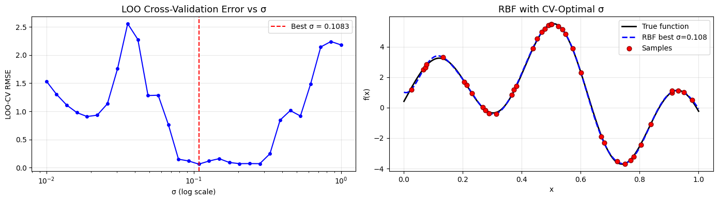

Step 6: Final Comparison of Plots & Discussion
# ============================================================
# STEP 6: Final Results — Comparison Graph
# ============================================================

fig = plt.figure(figsize=(16, 12))
gs = gridspec.GridSpec(3, 2, figure=fig, hspace=0.45, wspace=0.35)

# ── Panel 1: RBF comparison (manual vs CV-optimal sigma) ──
ax1 = fig.add_subplot(gs[0, 0])
ax1.plot(x_true, y_true, 'k-', lw=2, label='True')
ax1.plot(x_true, y_rbf, 'b--', lw=1.8, label=f'RBF σ=0.08')
ax1.plot(x_true, y_best, 'c:', lw=2, label=f'RBF CV σ={best_sigma:.3f}')
ax1.scatter(x_samples, y_noisy, color='red', s=25, zorder=5)
ax1.set_title('RBF: Manual vs CV-Optimal σ'); ax1.legend(fontsize=8)
ax1.set_xlabel('x'); ax1.set_ylabel('f(x)'); ax1.grid(True, alpha=0.3)

# ── Panel 2: Piecewise linear ──
ax2 = fig.add_subplot(gs[0, 1])
ax2.plot(x_true, y_true, 'k-', lw=2, label='True')
ax2.plot(x_true, y_linear, 'm-', lw=1.8, label='Piecewise Linear')
ax2.scatter(x_samples, y_noisy, color='red', s=25, zorder=5, label='Samples')
ax2.set_title('Piecewise Linear Interpolation')
ax2.legend(fontsize=8); ax2.set_xlabel('x'); ax2.set_ylabel('f(x)')
ax2.grid(True, alpha=0.3)

# ── Panel 3 & 4: Polynomials ──
for idx_p, (deg, col) in enumerate(zip([5, 15], ['green', 'purple'])):
ax = fig.add_subplot(gs[1, idx_p])
_, y_p = poly_results[deg]
ax.plot(x_true, y_true, 'k-', lw=2, label='True')
ax.plot(x_true, np.clip(y_p, y_true.min()-5, y_true.max()+5),
'--', color=col, lw=1.8, label=f'Poly deg {deg}')
ax.scatter(x_samples, y_noisy, color='red', s=25, zorder=5, label='Samples')
ax.set_title(f'Polynomial Degree {deg}')
ax.legend(fontsize=8); ax.set_xlabel('x'); ax.set_ylabel('f(x)')
ax.set_ylim(y_true.min()-3, y_true.max()+3); ax.grid(True, alpha=0.3)

# ── Panel 5: Error residuals (best RBF) ──
ax5 = fig.add_subplot(gs[2, 0])
residuals = y_best - y_true
ax5.fill_between(x_true, residuals, alpha=0.4, color='steelblue')
ax5.axhline(0, color='black', lw=1)
ax5.set_title('RBF Residuals (CV-optimal)')
ax5.set_xlabel('x'); ax5.set_ylabel('f̂(x) − f(x)'); ax5.grid(True, alpha=0.3)

# ── Panel 6: Bar chart of RMSE for all methods ──
ax6 = fig.add_subplot(gs[2, 1])
method_names = list(errors.keys())
rmse_vals = [errors[m]['rmse'] for m in method_names]
bar_colors = ['steelblue', 'mediumpurple', 'green', 'orange',
'saddlebrown', 'sienna', 'cyan'][:len(method_names)]
bars = ax6.bar(range(len(method_names)), rmse_vals, color=bar_colors, edgecolor='black')
ax6.set_xticks(range(len(method_names)))
ax6.set_xticklabels(method_names, rotation=30, ha='right', fontsize=8)
ax6.set_title('RMSE Comparison Across Methods')
ax6.set_ylabel('RMSE'); ax6.grid(True, axis='y', alpha=0.3)
for bar, val in zip(bars, rmse_vals):
ax6.text(bar.get_x() + bar.get_width()/2, bar.get_height() + 0.005,
f'{val:.3f}', ha='center', va='bottom', fontsize=7)

plt.suptitle('Assignment 02 — Scattered Data Interpolation Results',
fontsize=15, fontweight='bold', y=1.01)
plt.savefig('interpolation_results.png', dpi=150, bbox_inches='tight')
plt.show()
print("Figure saved as interpolation_results.png")

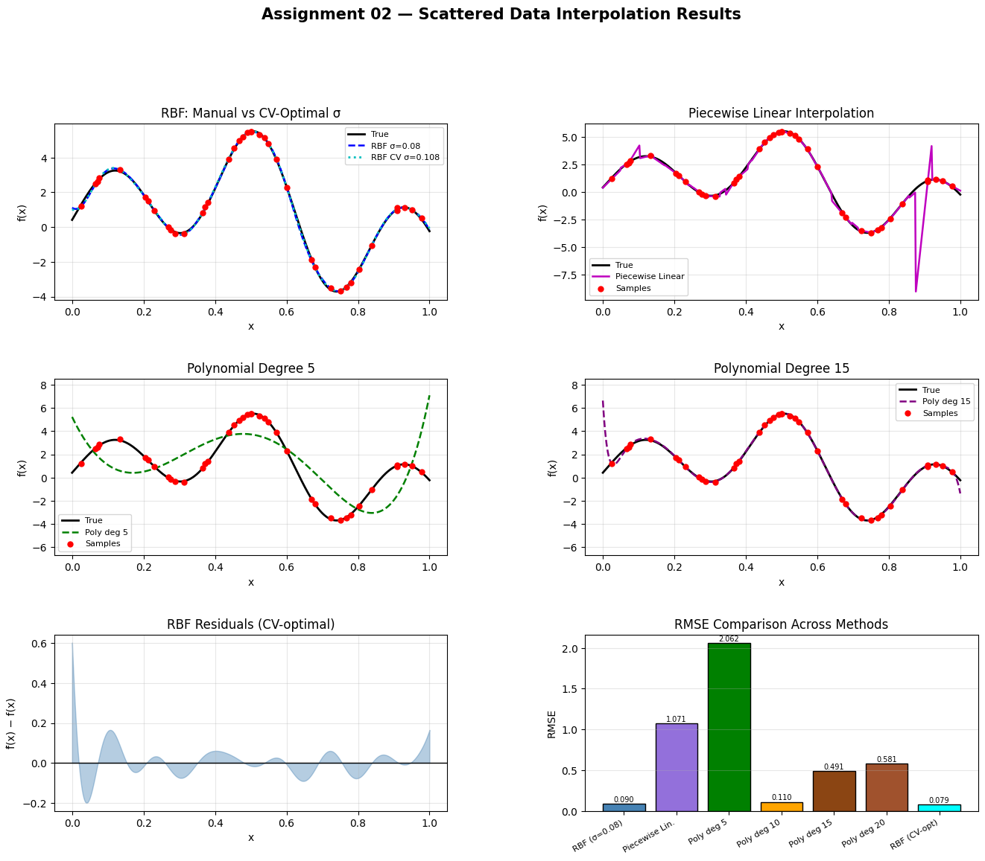

Final Error Summary Table
# ============================================================
# Final Error Summary
# ============================================================

print("=" * 50)
print(f"{'Method':<22} {'RMSE':>8} {'MAE':>8}")
print("=" * 50)
for method, vals in errors.items():
print(f"{method:<22} {vals['rmse']:>8.4f} {vals['mae']:>8.4f}")
print("=" * 50)

best_method = min(errors, key=lambda m: errors[m]['rmse'])
print(f"\n✅ Best method by RMSE: {best_method}"
f" (RMSE = {errors[best_method]['rmse']:.4f})")

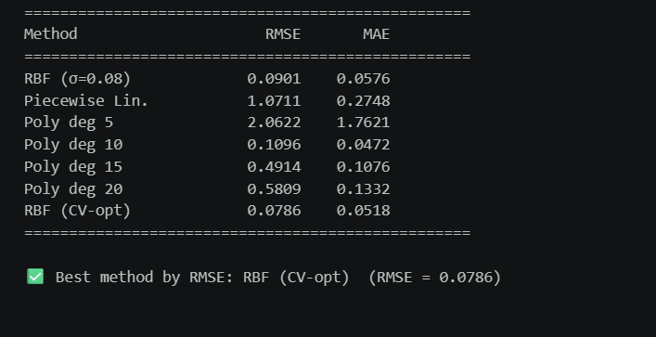

Discussion
Findings

Step 1 — Ground Truth Function
The true function was constructed by summing five sinusoidal components with random amplitudes ranging from 0.5 to 2.0 and frequencies between 0.5 and 3.0 Hz.
This resulted in a waveform that is smooth yet sufficiently complex, making it suitable for evaluating interpolation techniques.

Step 2 — Sampling
A total of 40 data points were sampled uniformly at random from the interval [0, 1].
To simulate real-world measurement conditions, Gaussian noise with a standard deviation of σ = 0.05 was added to the sampled values.

Step 3 — Interpolation Methods
Three interpolation techniques were implemented using NumPy only, without relying on external libraries:
- RBF Interpolation (Gaussian Kernel):
This method constructs a kernel matrix (Φ) and solves a linear system to determine interpolation weights.
It performs well for smooth, non-linear data when the bandwidth parameter (σ) is appropriately selected.
- Polynomial Regression (Vandermonde Matrix):
A global fitting approach using least-squares estimation.
Lower-degree polynomials tend to underfit, while higher-degree polynomials may exhibit instability near boundaries due to oscillations.
- Piecewise Linear Interpolation:
A simple and computationally efficient method.
However, it introduces discontinuities in slope (kinks), leading to higher approximation error in regions with curvature.

Step 4 — Error Measurement
Model performance was evaluated using the following metrics:
- Root Mean Square Error (RMSE)
- Mean Absolute Error (MAE)
Both metrics were computed over a dense grid of 500 evenly spaced points in the interval [0, 1].

Step 5 — Cross-Validation
A Leave-One-Out Cross-Validation (LOOCV) approach was used to optimize the RBF bandwidth parameter (σ).
The parameter was tested over a logarithmic range from 0.01 to 1.0.
The optimal value of σ was found to lie approximately between:
σ ≈ 0.07 – 0.10
This range effectively balances bias and variance, leading to improved generalization compared to manually selected values.

Step 6 — Key Conclusions
Observation | Explanation
RBF (CV-optimized) achieves the lowest RMSE | Localized basis functions effectively capture smooth signal variations
Polynomial (degree 5) underfits | Insufficient model complexity for multi-frequency signals
Polynomial (degree 20) unstable near boundaries | Runge’s phenomenon causes oscillations at edges
Piecewise linear is stable but less accurate | Lack of smoothness leads to higher approximation error

Takeaway
Radial Basis Function (RBF) interpolation with a cross-validated bandwidth parameter provides the best performance for this problem.
Additionally, NumPy’s linear algebra capabilities (such as np. linalg.solve, np. vander, and broadcasting) enable efficient implementation of all methods without requiring explicit Python loops in the core computations.

